PUMA FUNDAMENTAL SPORTS BAG
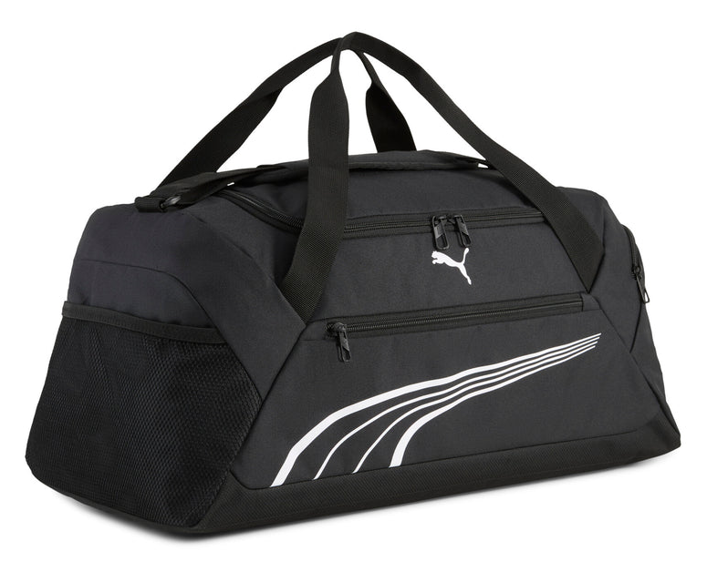
PRICE: Approximately Rs. 8,999

_{Introduction:}
The Puma Fundamental Sport Bag is a practical and durable carry solution designed for training, sports, and everyday activities. Built to handle daily use, this sport bag offers ample storage space while maintaining a lightweight and easy-to-carry design. Its clean and functional look makes it suitable for gym sessions, sports practice, or short trips. With strong construction and classic Puma branding, the Fundamental Sport Bag delivers reliability, comfort, and style for users with an active lifestyle.
Product Overview:
The Puma Fundamental Sport Bag features a spacious main compartment that comfortably holds workout gear, clothing, and essentials. Additional pockets help keep smaller items organized, while the sturdy handles and adjustable shoulder strap.
About the Brand:

Puma is a globally recognized sports and lifestyle brand known for combining performance, innovation, and modern design. Puma footwear is trusted worldwide for its comfort, durability, suitable for both athletic and casual wear.

Key Features:
- Spacious main compartment for sports gear
- Durable construction for daily use
- Adjustable shoulder strap for comfort
- Strong carry handles for easy lifting
- Additional pockets for small-item organization
- Classic Puma branding

Design & Build Quality:
The Puma Fundamental Sport Bag features a clean, structured design with reinforced stitching to enhance durability. Its sturdy base helps maintain shape, while quality zippers and seams ensure reliable performance during regular use.

Storage & Capacity:
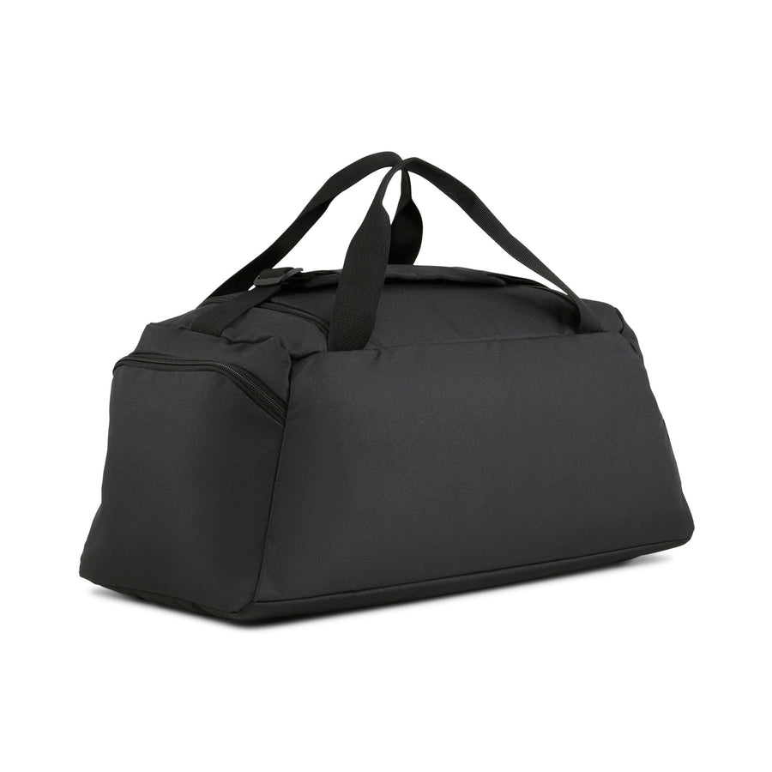
Designed to accommodate gym clothing, shoes, and accessories, the bag offers sufficient space for daily workouts or short trips. The internal layout allows easy organization, making it convenient for sports, travel, and everyday activities.

Material & Durability:
Constructed from high-quality polyester, the Puma Fundamental Sport Bag is built to withstand frequent use. The material resists wear and minor moisture exposure, ensuring your belongings remain protected.
Ideal For:
- Gym and training sessions
- Sports practice and activities
- Short trips and daily travel
- Users seeking a reliable sport bag

Care Instructions:
- Wipe clean with a damp cloth
- Do not machine wash or bleach
- Air dry away from direct sunlight
- Store in a dry place when not in use

Product Specifications:
- Brand: Puma
- Model: Fundamental Sport Bag
- Product Type: Sports / Gym Bag
- Material: Polyester
- Compartments: Main compartment + accessory pockets
- Strap Type: Adjustable shoulder strap
- Capacity: Medium

Product Summary:
The Puma Fundamental Sport Bag is a reliable and stylish choice for sports and everyday use. Offering spacious storage, durable construction, and comfortable carrying options, it meets the needs of active users with the trusted quality of Puma.

